Para entender los conceptos de tu catálogo web en relación con marcas populares como SensiHome y Adornus, la clave está en el tipo de perfil o moldura de la puerta. Ambos proveedores se enfocan en construcciones sin marco ("frameless" o estilo europeo) y paneles de alta calidad. [1]
Aquí tienes la explicación exacta de cada concepto técnico de tu imagen, alineado a lo que compras con ellos:
1. Modern Flat Panel (Panel Plano Moderno)
- Qué significa: Son puertas completamente lisas, limpias y sin ningún tipo de relieve o moldura.
- En tus proveedores: Corresponde exactamente a la línea Select de SensiHome (con acabados "super matte" o "high gloss") o las colecciones modernas de texturas europeas en Adornus. [1, 2, 3]
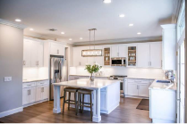

About - SensiHome - Kitchen & Bath Cabinets | Closets ...
mysensihome.com

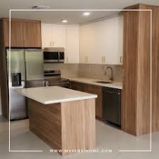

SensiHome LLC | Doral FL
facebook.com

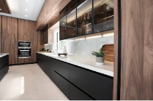

Alusso — Adornus
adornus.com

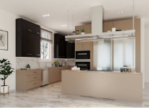

Alusso — Adornus
adornus.com

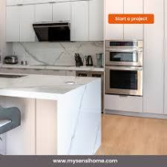

SensiHome - ✨ Elevate your kitchen experience with Sensi ...
m.facebook.com

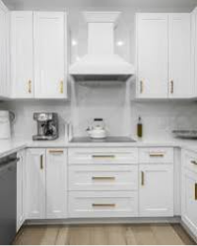

SensiHome LLC | Doral FL
facebook.com

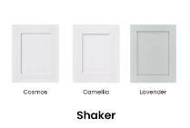

Home - SensiHome Cabinetry | Shaker, Select Modern, Closets ...
mysensihome.com

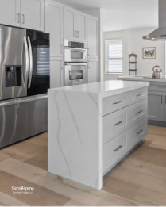

SensiHome (@mysensihome) · Miami, FL
instagram.com

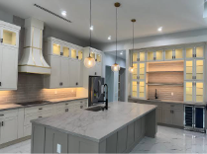

Designer Series — Adornus
adornus.com

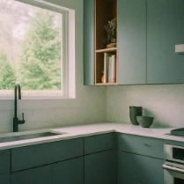

Choosing Adornus Cabinets: The Key to a Timeless Miami ...
adornus.com

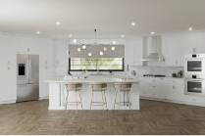

Essential Series — Adornus
adornus.com

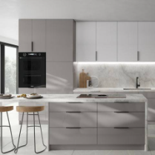

Premium Adornus Cabinets for Kitchens | Home Touch Design
hometouchdesign.com

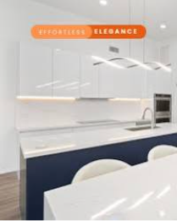

SensiHome LLC | Doral FL
facebook.com

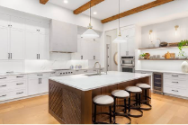

Products - SensiHome | Shop Shaker, Select Modern, Closets ...
mysensihome.com

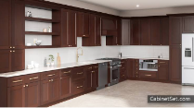

Sienna Shaker - High Quality Pre-Assembled Kitchen Cabinets ...
$626.34
cabinetset.com

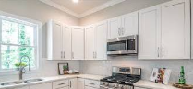

SensiHome LLC | Doral FL
facebook.com

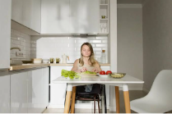

12 Unique Adornus Cabinet Designs to Inspire Your Next ...
adornus.com

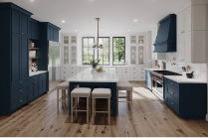

Resources — Adornus
adornus.com

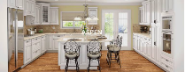

Adornus Cabinetry | Discount Cabinet Corner | www ...
discountcabinetcorner.com

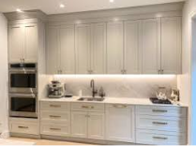

Transform your kitchen into a sanctuary of style and ...
instagram.com

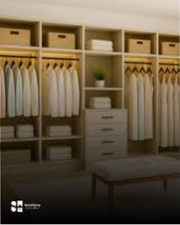

SensiHome LLC | Doral FL
facebook.com

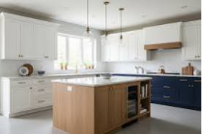

Kitchen Cabinet Ideas: Modern Styles, Layouts, and Design ...
goldenhomecabinets.com

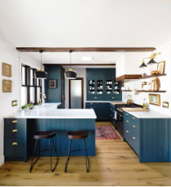

An Easy Guide to Understanding Kitchen Cabinet Styles ...
semistories.semihandmade.com

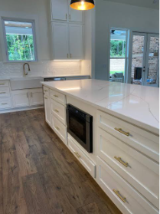

Wood Kitchen Cabinets | Cheap Kitchen Cabinets for Sale
centurycabinetsinc.com

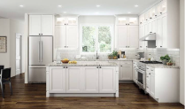

Premium Adornus Cabinets for Kitchens | Home Touch Design
hometouchdesign.com

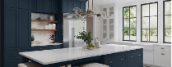

Adornus Cabinetry | Discount Cabinet Corner | www ...
discountcabinetcorner.com

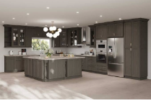

Adornus Cabinet Brand | Mudosi Kitchen and Bath
mudosikitchenandbath.com

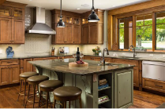

Adornus Cabinetry Updated Catalog • Golden Source Kitchen
goldensourcekitchen.com

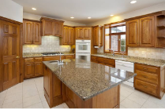

10 Kitchen Cabinet Styles to Consider for Your Next Renovation
bobvila.com

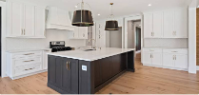

Our Style – Signature Companies
signaturecos.com

2. Classic Shaker (Shaker Clásico)
- Qué significa: El estilo más vendido del mercado. Consiste en un marco perimetral de cuatro piezas con un panel central hundido. El grosor del marco estándar suele ser de unas 2.75 a 3 pulgadas. [1]
- En tus proveedores: Son las líneas tradicionales de shaker como la serie Hampton de Adornus o las líneas básicas de Shaker en SensiHome (como los colores Cosmos o Camellia). [1, 2, 3]


Home - SensiHome Cabinetry | Shaker, Select Modern, Closets ...
mysensihome.com



Sienna Shaker - High Quality Pre-Assembled Kitchen Cabinets ...
$626.34
cabinetset.com



Essential Series — Adornus
adornus.com



Adornus Cabinetry | Discount Cabinet Corner | www ...
discountcabinetcorner.com



SensiHome - ✨ Elevate your kitchen experience with Sensi ...
m.facebook.com



About - SensiHome - Kitchen & Bath Cabinets | Closets ...
mysensihome.com



SensiHome LLC | Doral FL
facebook.com



SensiHome (@mysensihome) · Miami, FL
instagram.com



Alusso — Adornus
adornus.com



Designer Series — Adornus
adornus.com



Choosing Adornus Cabinets: The Key to a Timeless Miami ...
adornus.com



Premium Adornus Cabinets for Kitchens | Home Touch Design
hometouchdesign.com



SensiHome LLC | Doral FL
facebook.com



Products - SensiHome | Shop Shaker, Select Modern, Closets ...
mysensihome.com



SensiHome LLC | Doral FL
facebook.com



SensiHome LLC | Doral FL
facebook.com



12 Unique Adornus Cabinet Designs to Inspire Your Next ...
adornus.com



Resources — Adornus
adornus.com



Transform your kitchen into a sanctuary of style and ...
instagram.com



Alusso — Adornus
adornus.com



SensiHome LLC | Doral FL
facebook.com



Kitchen Cabinet Ideas: Modern Styles, Layouts, and Design ...
goldenhomecabinets.com



An Easy Guide to Understanding Kitchen Cabinet Styles ...
semistories.semihandmade.com



Wood Kitchen Cabinets | Cheap Kitchen Cabinets for Sale
centurycabinetsinc.com



Premium Adornus Cabinets for Kitchens | Home Touch Design
hometouchdesign.com



Adornus Cabinetry | Discount Cabinet Corner | www ...
discountcabinetcorner.com



Adornus Cabinet Brand | Mudosi Kitchen and Bath
mudosikitchenandbath.com



Adornus Cabinetry Updated Catalog • Golden Source Kitchen
goldensourcekitchen.com



10 Kitchen Cabinet Styles to Consider for Your Next Renovation
bobvila.com



Our Style – Signature Companies
signaturecos.com

3. Slim Shaker (Shaker Delgado)
- Qué significa: Una evolución moderna del Shaker. Mantiene el centro hundido, pero el marco exterior es extremadamente delgado (normalmente de solo 1/2 pulgada a 1 pulgada de grosor), dando un aspecto mucho más estilizado y lineal.
- En tus proveedores: Equivale exactamente a las líneas de catálogo Magnolia o Dahlia de SensiHome, y al modelo Fresno de Adornus. [1, 2, 3, 4]


Products - SensiHome | Shop Shaker, Select Modern, Closets ...
mysensihome.com



Kitchen Cabinet Ideas: Modern Styles, Layouts, and Design ...
goldenhomecabinets.com



Designer Series — Adornus
adornus.com



Premium Adornus Cabinets for Kitchens | Home Touch Design
hometouchdesign.com



SensiHome - ✨ Elevate your kitchen experience with Sensi ...
m.facebook.com



About - SensiHome - Kitchen & Bath Cabinets | Closets ...
mysensihome.com



SensiHome LLC | Doral FL
facebook.com



Home - SensiHome Cabinetry | Shaker, Select Modern, Closets ...
mysensihome.com



Alusso — Adornus
adornus.com



Choosing Adornus Cabinets: The Key to a Timeless Miami ...
adornus.com



Essential Series — Adornus
adornus.com



12 Unique Adornus Cabinet Designs to Inspire Your Next ...
adornus.com



SensiHome (@mysensihome) · Miami, FL
instagram.com



SensiHome LLC | Doral FL
facebook.com



SensiHome LLC | Doral FL
facebook.com



Sienna Shaker - High Quality Pre-Assembled Kitchen Cabinets ...
$626.34
cabinetset.com



Resources — Adornus
adornus.com



Adornus Cabinetry | Discount Cabinet Corner | www ...
discountcabinetcorner.com



Transform your kitchen into a sanctuary of style and ...
instagram.com



Alusso — Adornus
adornus.com



SensiHome LLC | Doral FL
facebook.com



SensiHome LLC | Doral FL
facebook.com



An Easy Guide to Understanding Kitchen Cabinet Styles ...
semistories.semihandmade.com



Wood Kitchen Cabinets | Cheap Kitchen Cabinets for Sale
centurycabinetsinc.com



Premium Adornus Cabinets for Kitchens | Home Touch Design
hometouchdesign.com



Adornus Cabinetry | Discount Cabinet Corner | www ...
discountcabinetcorner.com



Adornus Cabinet Brand | Mudosi Kitchen and Bath
mudosikitchenandbath.com



Adornus Cabinetry Updated Catalog • Golden Source Kitchen
goldensourcekitchen.com



10 Kitchen Cabinet Styles to Consider for Your Next Renovation
bobvila.com



Our Style – Signature Companies
signaturecos.com

4. Transitional (Transicional)
- Qué significa: No es un tipo de puerta en sí, sino una combinación de lo clásico y lo moderno. Utiliza la calidez de las texturas tradicionales (como la madera o puertas Shaker) pero con la distribución limpia y los herrajes simples de una cocina moderna. [1, 2, 3]


Wood Kitchen Cabinets | Cheap Kitchen Cabinets for Sale
centurycabinetsinc.com



12 Unique Adornus Cabinet Designs to Inspire Your Next ...
adornus.com



Transform your kitchen into a sanctuary of style and ...
instagram.com



Premium Adornus Cabinets for Kitchens | Home Touch Design
hometouchdesign.com



SensiHome - ✨ Elevate your kitchen experience with Sensi ...
m.facebook.com



About - SensiHome - Kitchen & Bath Cabinets | Closets ...
mysensihome.com



SensiHome LLC | Doral FL
facebook.com



Home - SensiHome Cabinetry | Shaker, Select Modern, Closets ...
mysensihome.com



Alusso — Adornus
adornus.com



Designer Series — Adornus
adornus.com



Choosing Adornus Cabinets: The Key to a Timeless Miami ...
adornus.com



Essential Series — Adornus
adornus.com



SensiHome (@mysensihome) · Miami, FL
instagram.com



SensiHome LLC | Doral FL
facebook.com



Products - SensiHome | Shop Shaker, Select Modern, Closets ...
mysensihome.com



SensiHome LLC | Doral FL
facebook.com



Premium Adornus Cabinets for Kitchens | Home Touch Design
hometouchdesign.com



Resources — Adornus
adornus.com



Adornus Cabinetry | Discount Cabinet Corner | www ...
discountcabinetcorner.com



Alusso — Adornus
adornus.com



Sienna Shaker - High Quality Pre-Assembled Kitchen Cabinets ...
$626.34
cabinetset.com



SensiHome LLC | Doral FL
facebook.com



SensiHome LLC | Doral FL
facebook.com



Kitchen Cabinet Ideas: Modern Styles, Layouts, and Design ...
goldenhomecabinets.com



Adornus Cabinetry | Discount Cabinet Corner | www ...
discountcabinetcorner.com



Adornus Cabinet Brand | Mudosi Kitchen and Bath
mudosikitchenandbath.com



Adornus Cabinetry Updated Catalog • Golden Source Kitchen
goldensourcekitchen.com

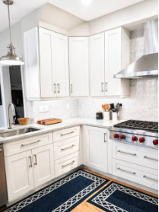

Adornus Cabinetry (@adornusproducts) • Facebook
facebook.com



An Easy Guide to Understanding Kitchen Cabinet Styles ...
semistories.semihandmade.com



10 Kitchen Cabinet Styles to Consider for Your Next Renovation
bobvila.com

5. Contemporary (Contemporáneo)
- Qué significa: Es un paso más allá de lo transicional, totalmente enfocado en las tendencias actuales. Suele priorizar cocinas Flat Panel con contrastes fuertes, gabinetes superiores que abren hacia arriba (push-to-open), iluminación LED integrada y combinaciones de colores atrevidos (verdes oscuros, grises mate o negros). [1, 2, 3]


SensiHome (@mysensihome) · Miami, FL
instagram.com



An Easy Guide to Understanding Kitchen Cabinet Styles ...
semistories.semihandmade.com



Choosing Adornus Cabinets: The Key to a Timeless Miami ...
adornus.com



Adornus Cabinetry | Discount Cabinet Corner | www ...
discountcabinetcorner.com



SensiHome - ✨ Elevate your kitchen experience with Sensi ...
m.facebook.com



About - SensiHome - Kitchen & Bath Cabinets | Closets ...
mysensihome.com



SensiHome LLC | Doral FL
facebook.com



Home - SensiHome Cabinetry | Shaker, Select Modern, Closets ...
mysensihome.com



Alusso — Adornus
adornus.com



Designer Series — Adornus
adornus.com



Essential Series — Adornus
adornus.com



Premium Adornus Cabinets for Kitchens | Home Touch Design
hometouchdesign.com



SensiHome LLC | Doral FL
facebook.com



Products - SensiHome | Shop Shaker, Select Modern, Closets ...
mysensihome.com



SensiHome LLC | Doral FL
facebook.com



Sienna Shaker - High Quality Pre-Assembled Kitchen Cabinets ...
$626.34
cabinetset.com



12 Unique Adornus Cabinet Designs to Inspire Your Next ...
adornus.com



Resources — Adornus
adornus.com



Adornus Cabinetry | Discount Cabinet Corner | www ...
discountcabinetcorner.com



Transform your kitchen into a sanctuary of style and ...
instagram.com



SensiHome LLC | Doral FL
facebook.com



SensiHome LLC | Doral FL
facebook.com



Kitchen Cabinet Ideas: Modern Styles, Layouts, and Design ...
goldenhomecabinets.com



Wood Kitchen Cabinets | Cheap Kitchen Cabinets for Sale
centurycabinetsinc.com



Alusso — Adornus
adornus.com



Premium Adornus Cabinets for Kitchens | Home Touch Design
hometouchdesign.com



Adornus Cabinet Brand | Mudosi Kitchen and Bath
mudosikitchenandbath.com



Adornus Cabinetry Updated Catalog • Golden Source Kitchen
goldensourcekitchen.com



10 Kitchen Cabinet Styles to Consider for Your Next Renovation
bobvila.com



Our Style – Signature Companies
signaturecos.com

6. Traditional (Tradicional)
- Qué significa: Estilo clásico americano. Las puertas suelen tener molduras internas más complejas o el panel central "realzado" (Raised Panel) en lugar de hundido. A menudo incluye detalles arquitectónicos como corbelas o vitrinas con marcos detallados. [1, 2, 3]


10 Kitchen Cabinet Styles to Consider for Your Next Renovation
bobvila.com



Our Style – Signature Companies
signaturecos.com



Adornus Cabinet Brand | Mudosi Kitchen and Bath
mudosikitchenandbath.com



Adornus Cabinetry Updated Catalog • Golden Source Kitchen
goldensourcekitchen.com



SensiHome - ✨ Elevate your kitchen experience with Sensi ...
m.facebook.com



About - SensiHome - Kitchen & Bath Cabinets | Closets ...
mysensihome.com



SensiHome LLC | Doral FL
facebook.com



Home - SensiHome Cabinetry | Shaker, Select Modern, Closets ...
mysensihome.com



Alusso — Adornus
adornus.com



Designer Series — Adornus
adornus.com



Choosing Adornus Cabinets: The Key to a Timeless Miami ...
adornus.com



Essential Series — Adornus
adornus.com



SensiHome (@mysensihome) · Miami, FL
instagram.com



SensiHome LLC | Doral FL
facebook.com



Products - SensiHome | Shop Shaker, Select Modern, Closets ...
mysensihome.com



SensiHome LLC | Doral FL
facebook.com



Premium Adornus Cabinets for Kitchens | Home Touch Design
hometouchdesign.com



12 Unique Adornus Cabinet Designs to Inspire Your Next ...
adornus.com



Resources — Adornus
adornus.com



Adornus Cabinetry | Discount Cabinet Corner | www ...
discountcabinetcorner.com



Sienna Shaker - High Quality Pre-Assembled Kitchen Cabinets ...
$626.34
cabinetset.com



SensiHome LLC | Doral FL
facebook.com



SensiHome LLC | Doral FL
facebook.com



Kitchen Cabinet Ideas: Modern Styles, Layouts, and Design ...
goldenhomecabinets.com



Transform your kitchen into a sanctuary of style and ...
instagram.com



Alusso — Adornus
adornus.com



Premium Adornus Cabinets for Kitchens | Home Touch Design
hometouchdesign.com



Adornus Cabinetry | Discount Cabinet Corner | www ...
discountcabinetcorner.com



An Easy Guide to Understanding Kitchen Cabinet Styles ...
semistories.semihandmade.com



Wood Kitchen Cabinets | Cheap Kitchen Cabinets for Sale
centurycabinetsinc.com

¿Te gustaría que preparemos las descripciones cortas en inglés y español para que las puedas copiar y pegar directamente en los textos de tu página web?
La IA puede cometer errores, así que verifica las respuestas
12 sitios
- Home - SensiHome Cabinetry | Shaker, Select Modern ...
Premium Features. Our Shaker lines are a stunning combination of classic beauty and modern elegance, perfect for any kitchen or ba...

SensiHome
- Designer Series — Adornus
The Designer Series is designed to meet any unique vision while maintaining quality and value. Some of the cabinet styles include:
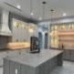
Adornus
- Slim Shaker - SensiHome Cabinetry
Magnolia – Slim Shaker. Magnolia is a slim shaker cabinet door in a light brown stain finish, featuring clean lines and refined pr...
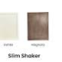
SensiHome
Mostrar todo
Dijiste pero estas imagenes pueden tener derecho de autor ? como puedo obtener imagenes que se vean reales pero no afectadas por derechos
Sí, las imágenes de catálogos oficiales y de internet tienen derechos de autor. Usarlas en tu sitio web comercial sin permiso te expone a multas o penalizaciones.
Para obtener imágenes con aspecto real, profesional y 100% libres de derechos de autor, utiliza estas dos opciones:
1. Bancos de fotos gratuitas (Licencia Pexels / Unsplash)
Estas plataformas ofrecen fotografías reales tomadas por profesionales que puedes usar gratis, incluso en páginas web de negocios, sin pagar nada.
- Pexels.com (Busca términos en inglés como: modern kitchen cabinets, shaker kitchen).
- Unsplash.com (Busca: flat panel kitchen, contemporary kitchen design).
- Pixabay.com (Busca: modern kitchen interior).
2. Generación de imágenes con Inteligencia Artificial (IA)
Es la mejor opción para conseguir exactamente el estilo de SensiHome o Adornus sin infringir derechos. Las imágenes generadas por IA son únicas, no existen en internet y puedes usarlas libremente en tu web comercial.
Aquí tienes los prompts (instrucciones) exactos que puedes copiar y pegar en herramientas gratuitas como Bing Image Creator, Midjourney o Leonardo.ai para obtenerlas:
- Para Modern Flat Panel:
High-end professional photography of a modern European-style kitchen, flat panel cabinets, matte finish, seamless handleless design, minimalist aesthetic, quartz countertops, studio lighting, commercial photography style, 8k --ar 4:3
- Para Classic Shaker:
Professional architectural photography of a transitional kitchen with classic shaker style cabinets, clean white shaker doors, elegant metal handles, marble countertop, bright and airy luxury interior, realistic texture, 8k --ar 4:3
- Para Slim Shaker:
Modern kitchen interior design, slim shaker cabinets, thin profile frame cabinetry, contemporary elegant look, warm oak accents, high-end real estate photography, photorealistic, 8k --ar 4:3
Si lo prefieres, dime qué colores de gabinetes te piden más tus clientes (blanco, gris, azul, madera) y puedo generar las imágenes directamente aquí con los estilos exactos de tu web. ¿Te gustaría que genere la primera?

